Devops:

New topics:

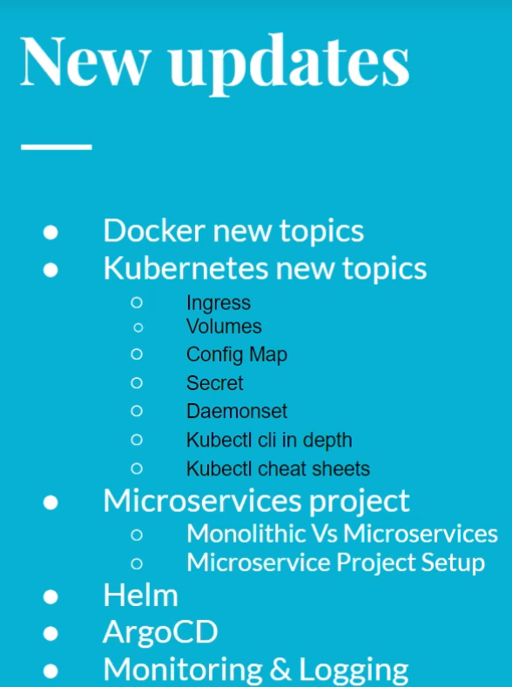

In devops:

The CI lifecycle:

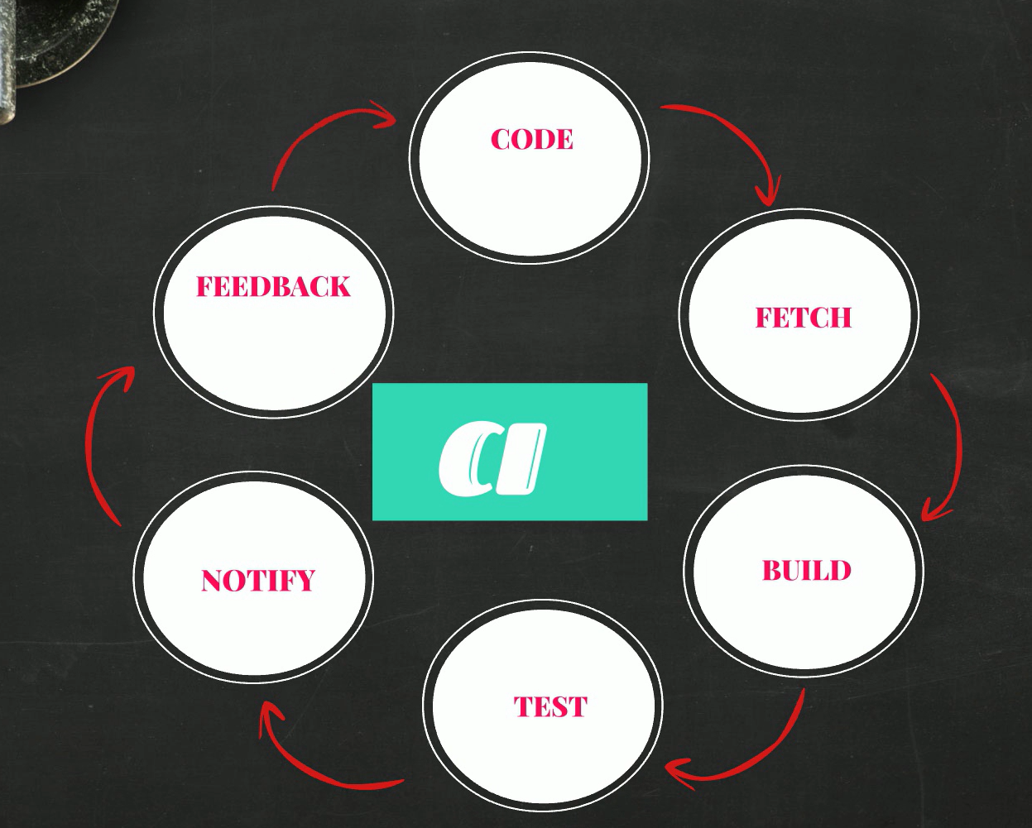

The CD

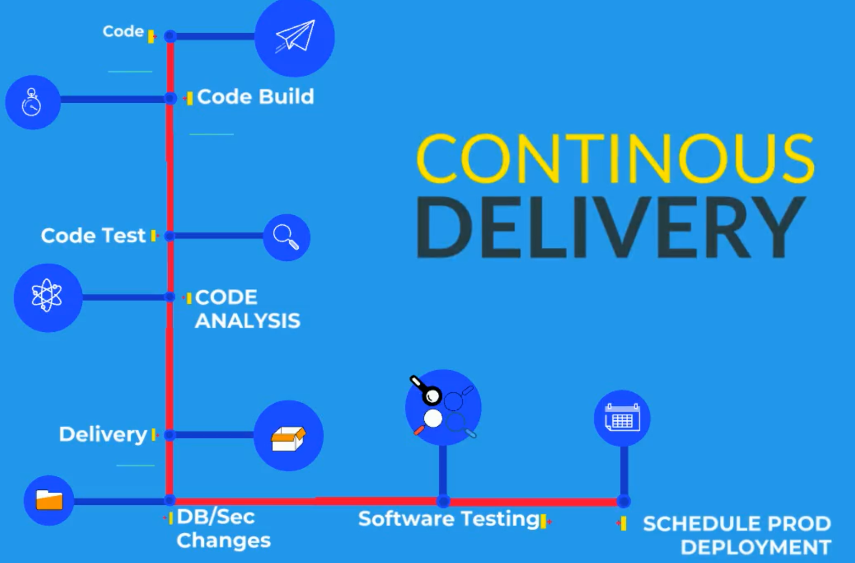

To install chocolatey: window,mac

<https://chocolatey.org/install>

1.paste and check policy: **Get-ExecutionPolicy**

2. Paste Set-ExecutionPolicy Bypass -Scope Process -Force; [System.Net.ServicePointManager]::SecurityProtocol = [System.Net.ServicePointManager]::SecurityProtocol -bor 3072; iex ((New-Object System.Net.WebClient).DownloadString('https://community.chocolatey.org/install.ps1'))

In window powershell

3. install virtulabox

Mac: homebrew

1.copy command and run it in terminal

2.virtual box

**Tools Prerequisites for Ubuntu 20**

#### ****Tools Prerequisites for Ubuntu 20****

**Install Virtualbox**

$ sudo apt update

$ sudo apt install virtualbox

**Install Vagrant**

$ curl -O <https://releases.hashicorp.com/vagrant/2.2.9/vagrant_2.2.9_x86_64.deb>

$ sudo apt install ./vagrant_2.2.9_x86_64.deb

**Install Git**

$ apt install git

**Install jdk8**

$ sudo apt-get install openjdk-8-jdk

**Install Maven**

$ sudo apt-get install maven

**Install awscli**

$ sudo apt-get install awscli

**Install Intellij community**

$ sudo snap install intellij-idea-community --classic

**Install Sublime Text**

$ sudo apt update

$ sudo apt install dirmngr gnupg apt-transport-https ca-certificates software-properties-common

$ curl -fsSL https://download.sublimetext.com/sublimehq-pub.gpg | sudo apt-key add -

$ sudo add-apt-repository "deb https://download.sublimetext.com/ apt/stable/"

$ sudo apt install sublime-text

Signup

1. GitHub
2. Domain purchase(godaddy)
3. Dockerhub
4. Sonarcloud

**Virtualization:**

VMware: Allows one computer to run multiple OS

Partition physical resource in virtual resource

Virtual machine runs in isolated Env

Each virtual machine needs its own OS

Server virtualization is the most common virtualization

Terminologies:

1. Host OS: OS of the physical machine, like ur laptop or desktop
2. Gest OS: OS of the virtual machine
3. VM: Short form of virtual machine
4. Snapshot: Is we take the backup of virtual machine
5. Hypervisor: Is a tool or software that create virtual machine, it enables VM
6. Two of Hypervisor:

**Type 1:**

Bare Metal

Runs as a base os on ur physical machine

Used only in production

Ex: VMware esxi, Xen Hypervisor

Type2:

Runs as a software

Install on any computer

Learn and test

Oracle vm

Type1 hypervisor can be Cluster together . we can distribute vm on the cluster hypervisor. If one VM goes down the other one runs.

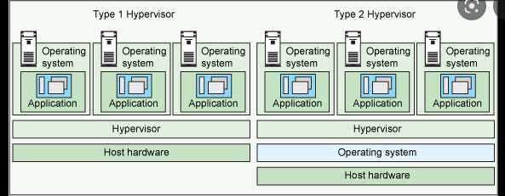

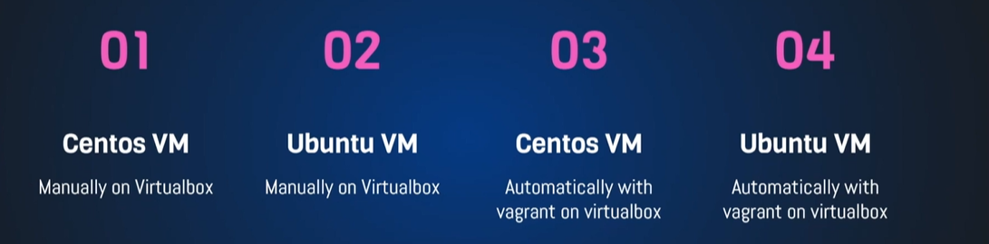

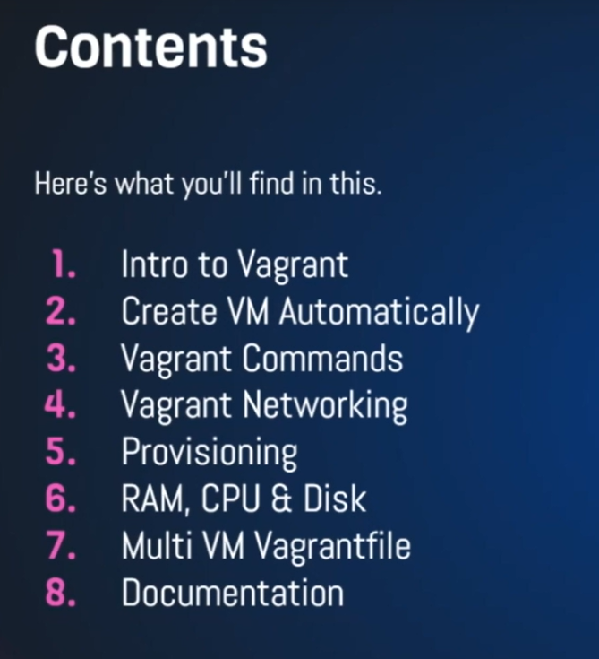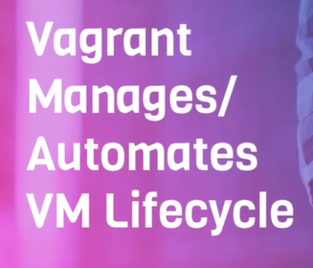

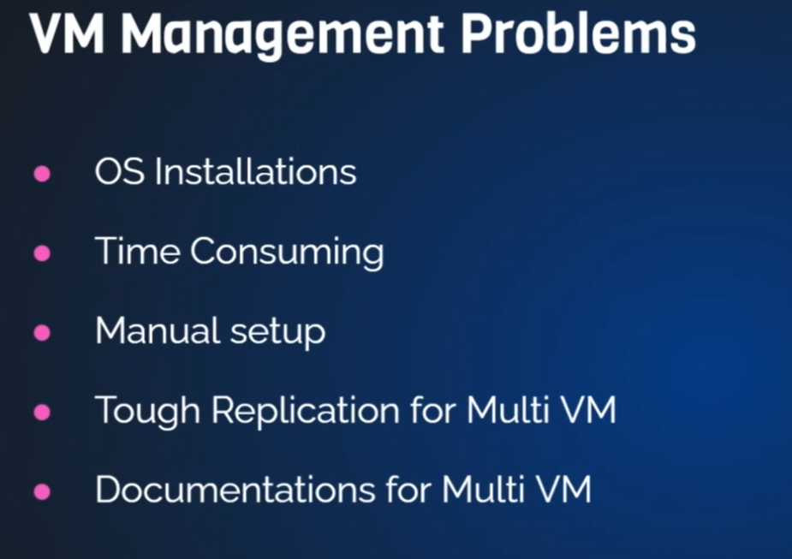

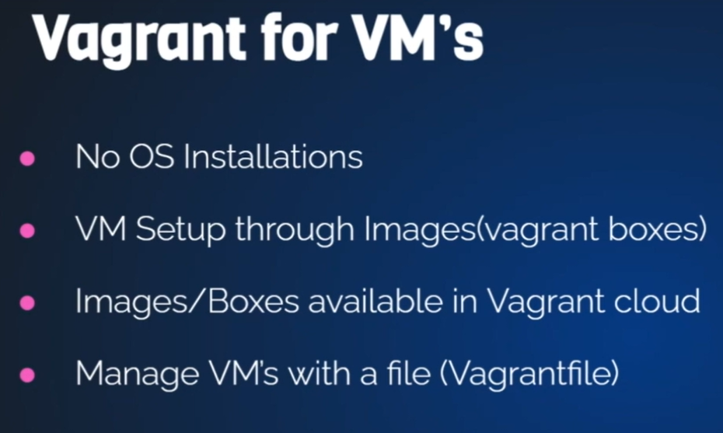

**To create Vagrant file: vagrant init name**

**Vagrant up**

**Vagrant ssh for login**

**Vagrant destroy: delete the vm**

**Vagrant reload : to reboot**

**History: to see the previous used command**

**Vagrant stop: vagrant halt**

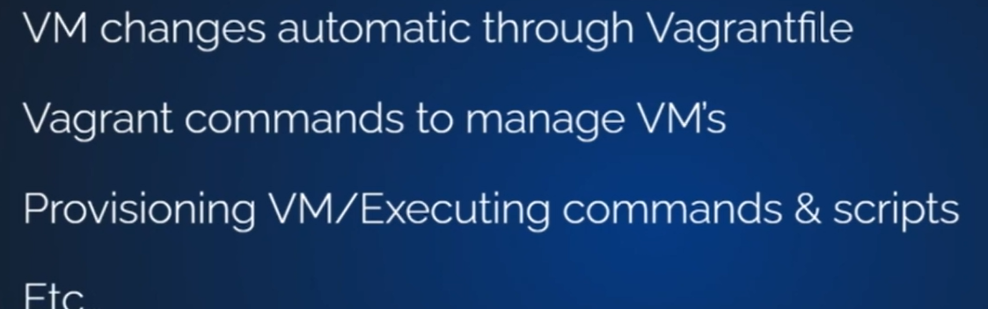

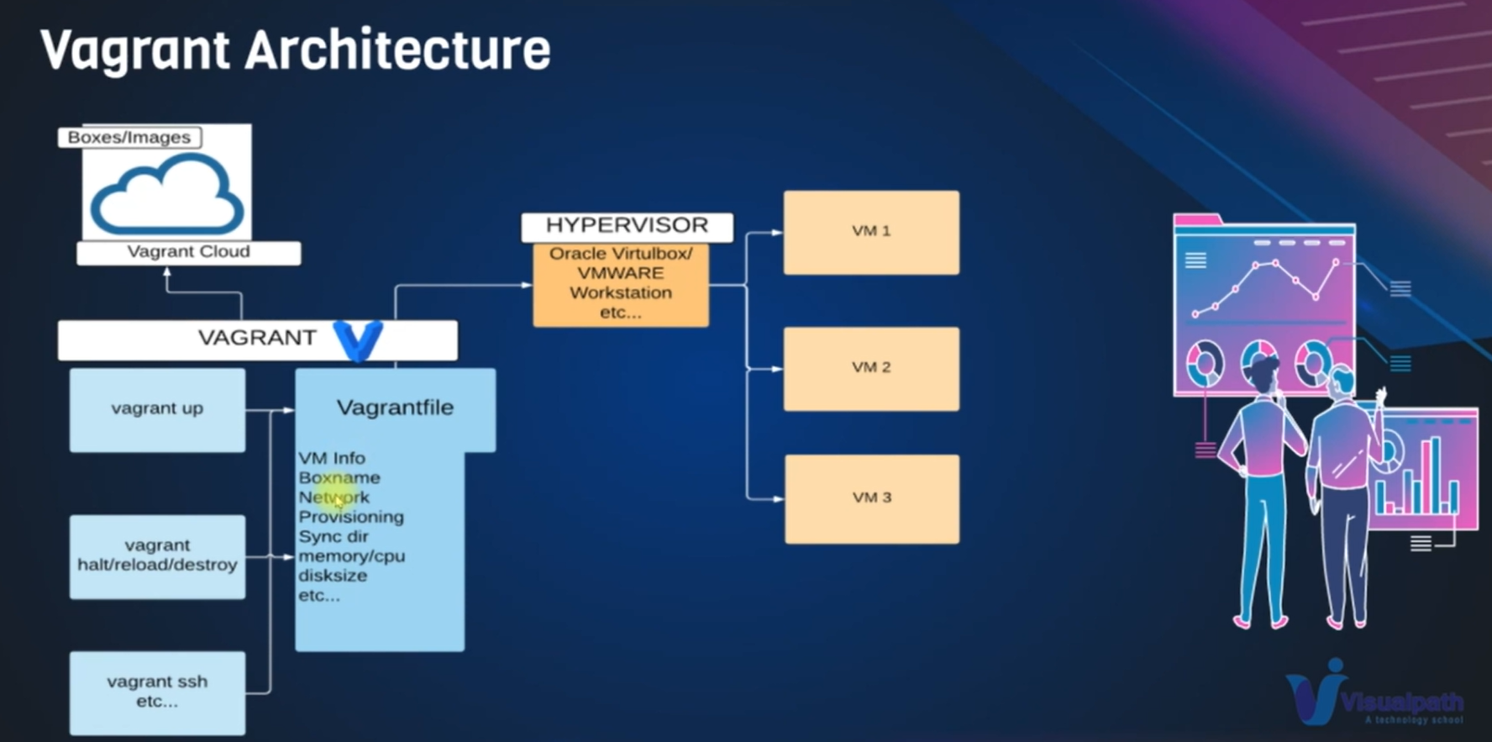

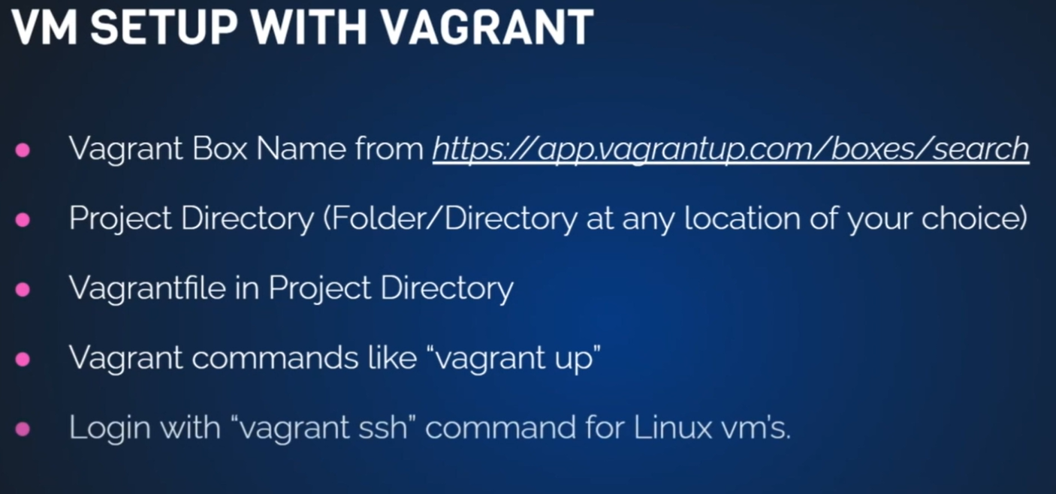

Linux:

1. Command
2. Files
3. Software’s
4. servers

Open sources:

**Linux principles:**

Everything is a file(include hardware)

Small single purpose program

Ability to chain program together for complex operations

Avoid captive user interface

Configuration data stored in text file

Popular Linux distros:

**List of Linux distribution:**

RPM extension(.rpm) and Debian (.deb)

**Some Important Directories:**

* Home Directories: /root,/home/username: /root is for administrator user and /home/username is normal user.
* User Executable command are commands that we run as ls, cat ,pwd these command will be located in /bin or, /usr/bin or, /usr/local/bin, these command will be executed by normal user.
* System Executables: /sbin, /usr/sbin, /usr/local/sbin , these command are executed by root user for installing the software.
* Other mountpoints: when we connect external harddisk it is mount in the /media, /mnt.
* Configuration: confirmation data will store in the /etc command like network confirmation, server confirmation, user confirmation.
* Temporary files: any temporary file can be add to /tmp command, but when u reboot it will deleted.
* Kernels and Bootloader are located in the /boot.
* Server data: the server information will store in the /var , /srv like website and mysql.
* System Information: will store in the /lib, /usr/lib, /usr/local/lib.
* Shared libraries : /lib , /usr/lib, /usr/local/lib

**Commands:**

* Promat:[vargant@localhost ~]$: for normal user.
* Promat:[root@localhost ~] #: for root user.
* ~ : is home directory
* whoami: name of the directory
* pwd: present working directory
* ls : Listing of files
* cat /etc/os-release : print file that is store in etc/os-release command
* change form normal to root: sudo -i

**Directory structure:**

Cd /: forward slash is the root directory

**Basic file base command:**

To home directory :cd ~

Coping one directory to other directory : cp -r directory1 to directory2

Syntax: command options arguments

Move command: mv can directly move from one directory to another . and also can rename using mv command

*:means everything

rm :remove command of file. rm -r : remove the directory.

rm -rf * remove all file and directory in that directory

history :displaying all command previous used

VIM:

yy: copy line in vim

p: paste below

P: paste above

dd: delete, 4dd :delete 4lines

u: undo

for search click /and type the name to search

linking file: if the file is large and have to make small, then use the: ln -s file_location new_name

cat new_name: display the file content.

If u what to remove means type: unlink new_name.

ls -lt: sort according to the present time

ls -ltr: sort according to the previous to first